**CNG KIT CYLINDER & PARTS MANGEMENT SYSTEM**

**OF**

**ENERGY ZONE**

**GROUP MEMBERS**

**MUHAMMAD UNAIS.17B-017-SE.SEM 1V SE-A**

**SHOAIB AHMED.17B-033-SE.SEM IV SE-A**

**HASSAN AHMED.17B-049-SE.SE A. SEM IV SE-A**

**ALI AKBAR.16B-056-SE. SEM IV SE-A**

**COURSE INSTRUCTOR**

**INSTRUCTOR NAME: USMAN WAHEED**

**TOPIC**

**BLACKBOX TESTING**

**USMAN INSTITUTE OF TECNOLOGY**

Contents

Control Testing 6

1. Textbox (Alphanumeric, Numeric, Alphabetic, Formatted) 6

Contributors 6

Step Based Guidance: 11

References: 11

2. Dropdown List Box 13

Contributors 13

Purpose 13

3. Command Buttons 16

Contributors 16

Purpose 16

Category: 16

Test cases (step based): 17

Guidelines 18

Reference: 19

Interface Testing 20

Contributors 20

**Add Customer Interface**

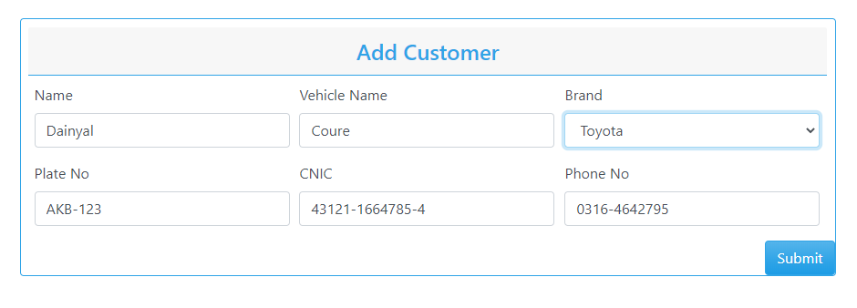

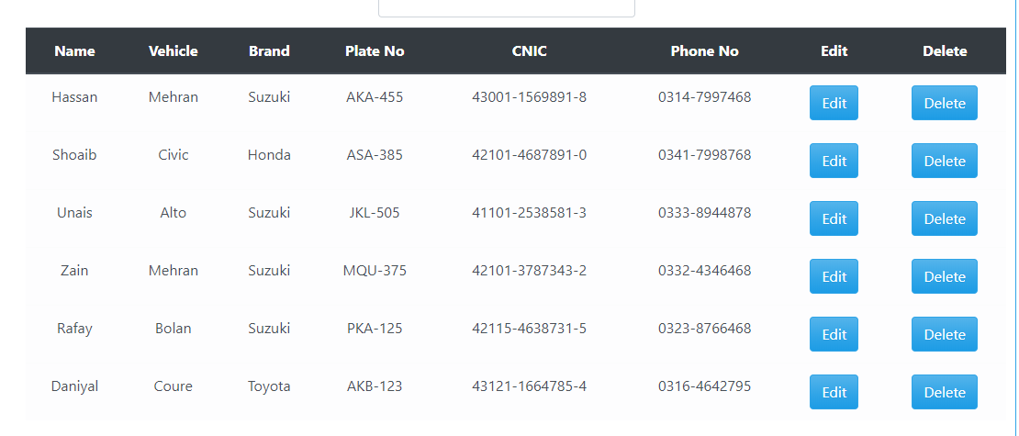

**List of 3 valid values**

|  |  |  |  |
| --- | --- | --- | --- |
| **Control name** | **Valid value 1** | **Valid value 2** | **Valid value 3** |
| Textbox (Alphabetic) | Hassan, Platz | HASSAN, PLATZ | Hassan, platz |
| Textbox (Formatted, Numeric) | 0332-3214569, 42115-4638731-5 | 0344-9852146, 42101-3787343-2, | 0310-3547896, 41101-2538581-3 |
| Textbox (Formatted, Alphanumeric) | AKA-455 | JKL-505 | MQU-375 |
| Dropdown list | - | - | - |
| Command button | - | - | - |

# Control Testing

### Textbox (Alphanumeric, Numeric, Alphabetic, Formatted)

### Contributors

SHOAIB AHMED, 17b-033-se@students.uit.edu, Usman Institute of Technology.

**Purpose**

Textboxes are text fields that enable the user to enter some text. The user can also display or edit a text or numeric value. Its purpose is to take input from the user. It is an input control unit. A text box is a rectangle of any size with a border that separates the text box from the rest of the interface. By clicking on textbox, a cursor is displayed so that you can begin typing. It is common for the [mouse](https://en.wikipedia.org/wiki/Computer_mouse) [cursor](https://en.wikipedia.org/wiki/Cursor_(computers)) to change its shape when it hovers over a text box. We can enter any type of text, it can be numeric, alphanumeric or alphabetic. Text box is used to enter and retrieve data to backend database, or can contain in some case default values.

**Example**

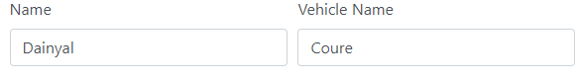

Figure 1: Textbox for alphabetic values

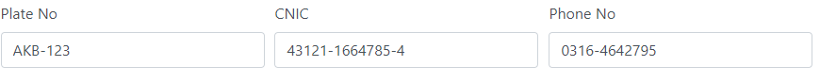

Figure 2: Textbox for alphanumeric formatted values



Figure 3: Textbox for numeric formatted values



Figure 4: Textbox for numeric formatted values

In Figure 1: **Daniyal and Coure** is an alphabetic text written in the textbox used for simple alphabetical data.

In Figure 2: **AKB-123** is an alphanumeric formatted CAR PLATE NUMBER text written in the textbox used for alphanumeric formatted data.

In Figure 3: **43121-1664785-4** is a numeric formatted CNIC text written in the textbox used for numeric formatted data.

In Figure 4: **0316-4642795** is a numeric formatted PHONE NO text written in the textbox used for numeric formatted data.

**Category:**

Input control

**Test case (input Based)**

* Does it only accept the alphabet values?

|  |  |  |  |
| --- | --- | --- | --- |
| Test case Name | Input | Output | Valid /Invalid |
| Alphabetic Data | Hafsa Akhter | Correct input | Valid |
| Hafsa4565 | Incorrect input | Invalid |

* Does it accept the numeric content?

|  |  |  |  |
| --- | --- | --- | --- |
| Test case Name | Input | Output | Valid /Invalid |
| Numeric data | Hafsa | Correct input | Valid |
| 35561 | Incorrect input | Invalid |

* Does it accept the symbols?

|  |  |  |  |
| --- | --- | --- | --- |
| Test case Name | Input | Output | Valid /Invalid |
| Symbolic Data | Hafsa | Correct input | Valid |
| ^hafsa | Incorrect input | Invalid |

* Does the text field accepts uppercase alphabets?

|  |  |  |  |
| --- | --- | --- | --- |
| Test case Name | Input | Output | Valid /Invalid |
| Uppercase alphabets | HAFSA | Correct input | Valid |
| HAFS67 | Incorrect input | Invalid |

* Does the text field accepts lowercase alphabets?

|  |  |  |  |
| --- | --- | --- | --- |
| Test case Name | Input | Output | Valid /Invalid |
| Lowercase alphabets | hafsa | Correct input | Valid |
| Hafsa538 | Incorrect input | Invalid |

* Does the text field accepts mix of upper and lowercase alphabets?

|  |  |  |  |
| --- | --- | --- | --- |
| Test case Name | Input | Output | Valid /Invalid |
| Upper and lowercase alphabets | HaFsA | Correct input | Valid |
| HaFsA35561 | Incorrect input | Invalid |

* Does the text field allows copy paste?

|  |  |  |  |
| --- | --- | --- | --- |
| Test case Name | Input | Output | Valid /Invalid |
| Copy paste | HaFsA | Copied Text | Valid |
| HaFsA35561 | Original Text | Invalid |

* Does the text field allow drag and drop of text content?

Some of the text Fields do allow drag and drop of text contents and some don’t so the accepting condition is shown.

|  |  |  |  |  |
| --- | --- | --- | --- | --- |
| Test case Name | Input | Conditions | Output | Valid /Invalid |
| Alphanumeric Data | HaFsA | Drag And Drop Text | Function Working | Valid |
| HaFsA35561 | Original Text | Function working | Valid |

* Does the text field allows spaces?

|  |  |  |  |
| --- | --- | --- | --- |
| Test case Name | Input | Output | Valid /Invalid |
| Allows spaces | HafsaAkhtar | Correct input | Valid |
| Hafsa Akhtar | Correct Input | Valid |

* Does the textbox field is editable after retrieving data from Database?

|  |  |  |  |
| --- | --- | --- | --- |
| Test case Name | Input | Output | Valid /Invalid |
| Retrieving data from Database | Data retrieved from database | Data Showed | Valid |
| Hassan123 or Hassan | Data is editable | Valid |

* Does its limit is 20 character for name?

|  |  |  |  |
| --- | --- | --- | --- |
| Test case Name | Input | Output | Valid /Invalid |
| Alphabetic Data | Mustansar Hussain tarrar | Textbox filled green display | Valid |
| Mustansar Hussain tarrar ahmedia | Please enter less than 21 character | Invalid |

* Does its limit is 12 character for vehicle name?

|  |  |  |  |
| --- | --- | --- | --- |
| Test case Name | Input | Output | Valid /Invalid |
| Alphabetic Data | Corolla | Textbox filled green display | Valid |
| Corolla city platz | Please enter less than 13 character | Invalid |

* Does its min limit is 3 character for name?

|  |  |  |  |
| --- | --- | --- | --- |
| Test case Name | Input | Output | Valid /Invalid |
| Alphabetic Data | Ali | Textbox filled green display | Valid |
| Al | Enter 3 character | Invalid |

* Does its limit is 2 character for vehicle name?

|  |  |  |  |
| --- | --- | --- | --- |
| Test case Name | Input | Output | Valid /Invalid |
| Alphabetic Data | AD | Textbox filled green display | Valid |
| A | Enter 2 character | Invalid |

* Does the “Formatted Textbox” which should have proper format predefined and accepting the same number characters in the same format for ex: CNIC number should accept XXXX-XXXXXXXX-X in this format and - - characters should be displayed in TextBox before entering anything in CNIC field?

|  |  |  |  |
| --- | --- | --- | --- |
| Test case Name | Input | Output | Valid /Invalid |
| Formatting | 4215-25461252-8 | Textbox filled green display | Valid |
| Abcd-456-sadhbd-hel | CNIC number should accept XXXX-XXXXXXXX-X format | Invalid |

* Does the “Formatted Textbox” which should have proper format predefined and accepting the same number characters in the same format for ex: CNIC number should not accept all zero number in this in CNIC field?

|  |  |  |  |
| --- | --- | --- | --- |
| Test case Name | Input | Output | Valid /Invalid |
| Formatting | 4215-25461252-8 | Textbox filled green display | Valid |
| 0000-00000000-0 | CNIC number should not accept all zero. | Invalid |

* Does the “Formatted TextBox” which should have proper format predefined and accepting the same number characters in the same format for ex: phone number should accept XXXX-XXXXXXX in this format and - - characters should be displayed in Textbox before entering anything in phone number. field?

|  |  |  |  |
| --- | --- | --- | --- |
| Test case Name | Input | Output | Valid /Invalid |
| Formatting | 0332-5647891 | Textbox filled green display | Valid |
| 03-32564789-1 | Phone number should accept XXXX-XXXXXXX format | Invalid |

* Does the “Formatted Textbox” which should have proper format predefined and accepting the same number characters in the same format for ex: phone number should not accept all zero number in this in phone number field?

|  |  |  |  |
| --- | --- | --- | --- |
| Test case Name | Input | Output | Valid /Invalid |
| Formatting | 0312-1254789 | Textbox filled green display | Valid |
| 0000-0000000 | Phone number should not accept all zero number | Invalid |

* Does the “Formatted Textbox” which should have proper format predefined and accepting the same number characters in the same format for ex: phone number should 03 format number in this in phone number field?

|  |  |  |  |
| --- | --- | --- | --- |
| Test case Name | Input | Output | Valid /Invalid |
| Formatting | 0312-1254789 | Textbox filled green display | Valid |
| 0212-1254789 | Phone number should 03 format number | Invalid |

* Does the “Formatted Textbox” which should have proper format predefined and accepting the same number characters in the same format for ex: phone number should contain 0300 to 0349 format number in this in phone number field?

|  |  |  |  |
| --- | --- | --- | --- |
| Test case Name | Input | Output | Valid /Invalid |
| Validation of first 4 numbers | 0349-1254789 | Textbox filled green display | Valid |
| 0360-1254789 | Phone number should contain 0300 to 0349 | Invalid |

* Does the “Formatted TextBox” which should have proper format predefined and accepting the same number characters in the same format for ex: car plate no should accept XXX-XXX in this format and - - characters should be displayed in Textbox before entering anything in car plate no field?

|  |  |  |  |
| --- | --- | --- | --- |
| Test case Name | Input | Output | Valid /Invalid |
| Formatting | AKB-121 | Textbox filled green display | Valid |
| AK-B121 | Car plate no should accept XXX-XXX format | Invalid |

* Does the “Formatted TextBox” which should have proper format predefined and accepting the same number characters in the same format for ex: car plate no should not accept numbers in first 3 alphabet and alphabet in last three number in car plate no field?

|  |  |  |  |
| --- | --- | --- | --- |
| Test case Name | Input | Output | Valid /Invalid |
| Formatting | AKB-121 | Textbox filled green display | Valid |
| AK1-B21 | Car plate no should not accept numbers in first 3 alphabet and alphabet in last three number | Invalid |

* Does the “Formatted TextBox” which should have proper format predefined and accepting the same number characters in the same format for ex: car plate no should accept all zero in car plate no field?

|  |  |  |  |
| --- | --- | --- | --- |
| Test case Name | Input | Output | Valid /Invalid |
| Zero value | AKB-121 | Textbox filled green display | Valid |
| 000-000 | Car plate no should accept all zero | Invalid |

### Step Based Guidance:

* Does Moving the Mouse Cursor over all Enterable Text Boxes. Do Cursor change from arrow to Insert Bar.

**Guide lines**

* Does the blinking cursor appear while typing the content?
* Does the characters that are type in the textbox are in the right format?
* Does it show RED asterisk for mandatory fields? (as per requirements)
* Does the correct “Text” associate with Textbox?
* Does it have the correct formatted pattern for the “Formatted Textbox”?
* Does the cursor change from arrow to Insert Bar when moved over all textboxes?
* Does the formatted textbox not accept less than allocated characters?
* Does the textbox stop accepting when reached its allocated characters by overflowing the in textbox?

### References:

1. “Graphical UI Testing Checklist”, https://www.stickyminds.com/sites/default/files/article/file/2014/Graphical%20UI%20Testing%20Checklist.pdf

**What else not included:**

* Check for RED asterisk for mandatory fields. (as per requirements)
* Enter continuous characters still it stops to enter any character and measure width of the TextBox. It should stop you and width should be as per requirement.
* Enter valid value in mandatory Textbox and save the window. Again come to same window and delete that value and test if it asks for value as it is mandatory
* If value is coming from DB then check if you can edit same.

-

* If value is coming from DB then check if the value is correct and populating correctly.
* SHIFT and Arrow should Select Characters. Selection should also be possible with mouse. Double Click should select all text in box.
* Move the Mouse Cursor over all Enterable Text Boxes. Cursor should change from arrow to Insert Bar.

### Dropdown List Box

### Contributors

SHOAIB AHMED, 17b-033-se@students.uit.edu, Usman Institute of Technology.

### Purpose

The purpose of drop-down list box, users make a choice among a list of mutually exclusive values. Users can choose one and only one option. With a standard drop-down list, users are limited to choices in the list.

**Example**

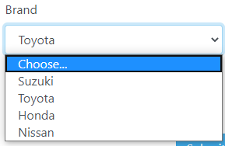

Figure 1 Dropdown list Box

In Figure 1: we have dropdown list box with several option in which we can any option from the given list, such as we have selected car brand.

**Category: Selective Control**

**Test cases (step based)**

* Do click on the arrow of the control and check if list should be displayed?

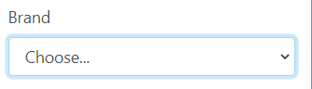

Figure 2 Car Brand Drop Down List Box

Select any one option from the list

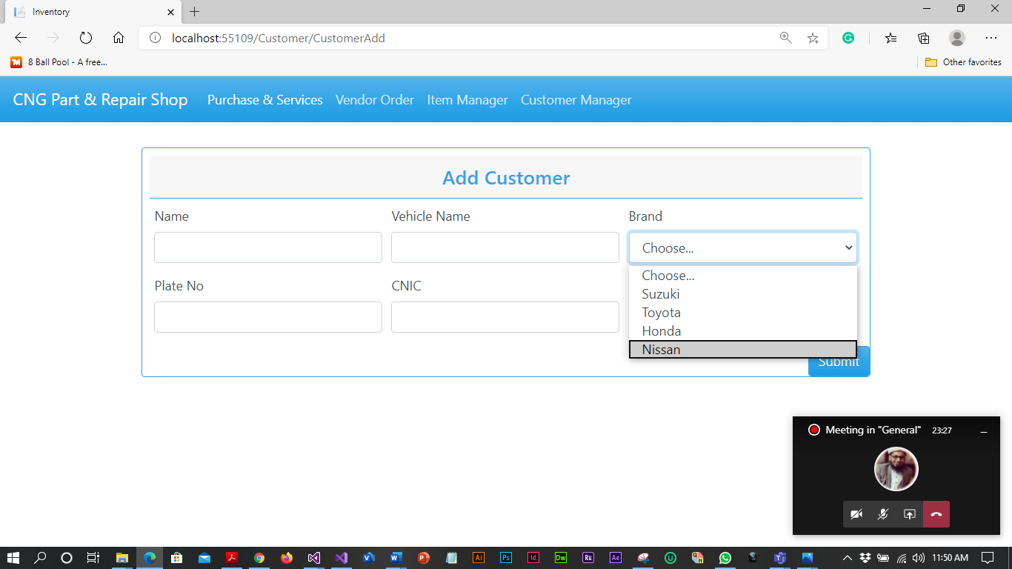

Figure 3 Car Brand Drop Down List

Car brand would be selected according to the selected method



Figure 3 Car Brand Selected Drop Down List

**Guide lines**

* Do check for appropriate sign displayed (as arrow) over control.
* Do check for default value that should be displayed or it should be BLANK.
* Do check if list contains number of values then “Scroll” option should display and it should be working.
* Do check for alignment of list is associated with control.
* Do check for “TEXT” identifier displayed with the control.
* Do check after clicking on arrow image should display as clicked.
* Does all the dropdowns on this screen sorted correctly? Alphabetic sorting is the default unless otherwise specified.
* Do ensure that the names are not abbreviations / cut short
* Does the design of the drop-down i.e. its alignment with other items on the page on all common browsers?
* Does that the drop-down accommodates the longest text within its boundary.
* Does that the drop-down can be scrolled down on clicking the down arrow.
* Does that the drop-down has a proper title.
* Does that the default item is getting displayed when the user first visits the page.
* Does that on clicking the down arrow all items are getting listed in its expected order.
* Does the spelling, font and style of the text inside the drop-down.
* Does that on clicking the categories, the page displays the corresponding items.
* Does that the selected category is getting highlighted on selecting the item.
* Does the time taking in loading the items under each category? Too much time should not be taken for loading the items.
* Does the correctness of the items in this drop-down is ensured? If the list (of items) of this drop-down is controlled by some other selection (say in another drop-down or check-box, radio-button)
* If the selection in this drop-down is controlling some other control (say, enabling/disabling etc) then check the proper action.
* Does on pressing an alphabet on the keyboard, categories starting with that alphabet is getting highlighted.
* Does the user is able to select the categories/items by pressing the down key on the keyboard.

**References**

[1] on 31st August 2012 / by minu.podipara, et al. “How to Test Drop down Lists on Websites?” Digital Solutions Provider, www.zyxware.com/articles/4291/how-to-test-drop-down-lists-on-websites.

### Command Buttons

### Contributors

SHOAIB AHMED, 17b-033-se@students.uit.edu, Usman Institute of Technology.

### Purpose

The command buttons are small rectangle on a graphical user interface with a command, such as open, close, OK, or print, With a command button, users initiate an immediate action by clicking on it .It provides the user a simple way to trigger an event like: SAVE button is used to save the values at the backend or the database. The source of this kind of control is the backend and the type or the category of it is clickable (selectable) because there is no need to input any kind of data and they do not provide any kind of output they only trigger an event of your choice

**Example**

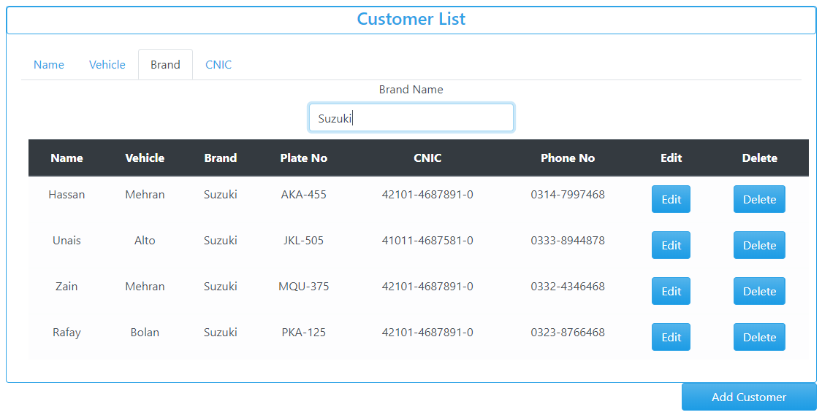

Figure 1: ADD, EDIT, DELETE Button

In Figure 1: In figure edit delete and add button are shown by pressing it they will perform add delete edit functions respectively.

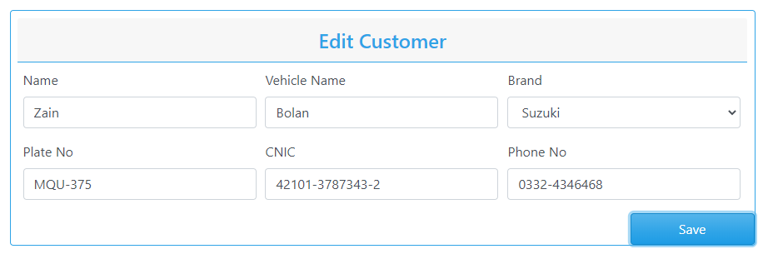

Figure 3: Save Button

Figure 2: Submit Button

In Figure 3: In figure submit button is shown by pressing it they will perform submit function.

In Figure 4: In figure save button is shown by pressing it they will save function.

### 

### Category:

The type or the category of it is clickable (selectable)

### Test cases (step based):

1. Do check appropriate TEXT associated with the button or not.?

**Steps:**

a: Open add customer

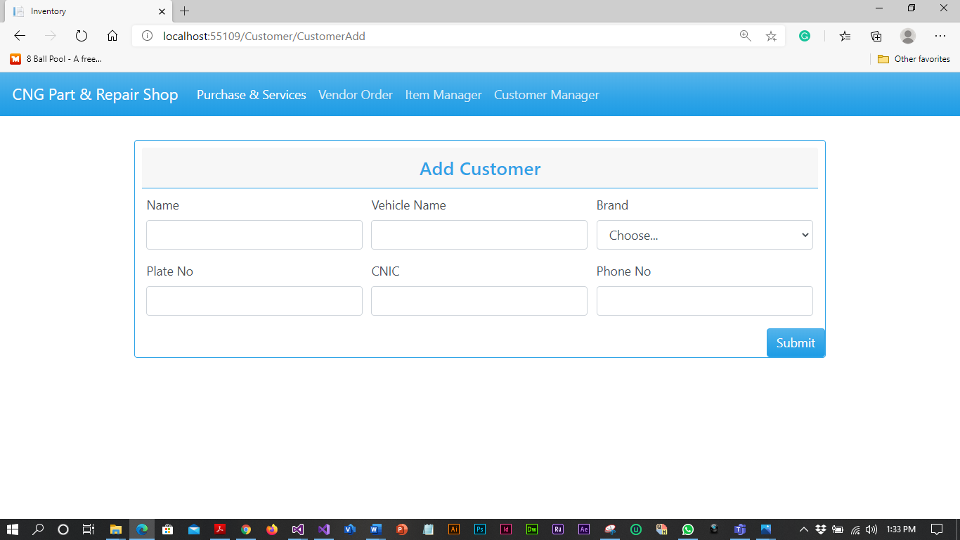

Figure 4:Empty customer add interface

b: Filled customer information



Figure 5: Filled customer add interface

c: After pressing submit button customer is added to the system



Figure 6: customer added

### Guidelines

* Does a text no more than three words in length with all significant first letters capitalized? The use of text is recommended over graphics, it provides a more consistent interface with standard applications.
* Do check whether expected result is displayed on click?
* Do Check the font size of button?
* Do Check the font color of button?
* Do Check the size of button?
* Check the spelling mistake of the label of the button?
* Do buttons labeled with mixed case text that describes the button's behavior, graphics that are easily interpreted, or a combination of both?
* Does a command button process triggers when a mnemonic is selected?
* Do the command buttons are logically grouped? Is this grouping made by white space or not group boxes?
* Do all command buttons are of same dimensions?
* When arranging buttons, do most frequently used buttons located in preferred locations (without violating consistency of location)?
* When arranged left-to-right, do more frequent actions place on the left?
* When arranged vertically, do more frequent actions place at the top?
* Does appropriate TEXT associated with the control, checked?
* Does the label of the control have appropriate naming convention?
* Do pointer is displayed busy when the result of clicking a command isn’t instantaneous?
* Do you use same label text and access key, and locate it in approximately the same place in each window when practical if the same command button appears in more than one window?
* Do you use a minimum button width and the standard command button height for the command button with text label?
* Do you vertically stack them to the right of and top-aligned with the other control, or horizontally place them left-aligned under the control if multiple command button interoperates with the same control?
* Do you use narrow, short, or tall command buttons with text labels?
* Do you make the most likely command the default behavior?
* Do you change the button label to the last selection if the most likely command is the last user selection?
* Do you display default command using bold text in the menu?
* Does a process invoked by a command button is not valid or is the button disabled by dimming the text and disallowing the selection?

### Reference:

1. Atul. “Graphical UI Testing Checklist.” Stickyminds, www.stickyminds.com/sites/default/files/article/file/2014/Graphical%20UI%20Testing%20Checklist.pdf.

**STRATEGY**

* Open the interface of add customer.
* Filled all the controlled in an interface related to the customer.
* Clicked the submit button to save the customer.

**Interface Testing**

1. **Aesthetic Conditions:**

### Contributors

Ali Akbar Channa, [akbarchanna94@gmail.com](mailto:akbarchanna94@gmail.com), Usman Institute of Technology.

**Purpose**The purpose is to better understand how user interacts with product and to improve product based on the results. The purpose of this test is improve the design in a typical aesthetic test. The real users try to accomplish typical goals or task with a product under controlled condition

**Checklist**

Is the general screen background the correct color?

2. Are the field prompts the correct color?

3. Are the field backgrounds the correct color?

4. In read-only mode, are the field prompts the correct color?

5. In read-only mode, are the field backgrounds the correct color?

6. Are all the screen prompts specified in the correct screen font?

7. Is the text in all fields specified in the correct screen font?

8. Are all the field prompts aligned perfectly on the screen?

9. Are all the field edit boxes aligned perfectly on the screen?

10. Are all group boxes aligned correctly on the screen?

11. Should the screen be resizable?

12. Should the screen be minimzable?

13. Are all the field prompts spelt correctly?

14. Are all character or alpha-numeric fields left justified? This is the default unless otherwise specified.

15. Are all numeric fields’ right justified? This is the default unless otherwise specified.

16. Is all the micro help text spelt correctly on this screen?

17. Is all the error message text spelt correctly on this screen?

18. Is all user input captured in UPPER case or lower case consistently?

19. Where the database requires a value (other than null) then this should be defaulted into fields. The user must either enter an alternative valid value or leave the default value intact.

20. Assure that all windows have a consistent look and feel.

21. Assure that all dialog boxes have a consistent look and feel.

**Test case (input Based)**

**User Error**

|  |  |  |  |
| --- | --- | --- | --- |
| Controls | Input | Output | Valid /Invalid |
| Text box | Value exceeds | Alert | Invalid |
| Text box | Out of range | prompt | Valid |

**Multiple validation rules**

|  |  |  |  |
| --- | --- | --- | --- |
| Controls | Input | Output | Valid /Invalid |
| Text box | Once the value is stored it will automatic appeared as suggestion for second time | duplicate | Valid |

**Numeric validation rules**

|  |  |  |  |
| --- | --- | --- | --- |
| Controls | Input | Output | Valid /Invalid |
| Text box | Matching the data values | Alert out of range | Valid |

**Invalid entry**

|  |  |  |  |
| --- | --- | --- | --- |
| Controls | Input | Output | Valid /Invalid |
| Text box | Special character | Not a number | Valid |
| Text box | Letter | Not a number | Valid |

### 

### Guidelines

* Does a text no more than three words in length with all significant first letters capitalized? The use of text is recommended over graphics, it provides a more consistent interface with standard applications.
* Do check whether expected result is displayed on click?
* Do check the font size of button?
* Do check the font color of button?
* Do check the size of button?
* Check the spelling mistake of the label of the button?
* Do buttons labeled with mixed case text that describes the button's behavior, graphics that are easily interpreted, or a combination of both?
* Does a command button process triggers when a mnemonic is selected?
* Do the command buttons are logically grouped? Is this grouping made by white space or not group boxes?
* Do all command buttons are of same dimensions?
* When arranging buttons, do most frequently used buttons located in preferred locations (without violating consistency of location)?
* When arranged left-to-right, do more frequent actions place on the left?
* When arranged vertically, do more frequent actions place at the top?
* Does appropriate TEXT associated with the control, checked?
* Does the label of the control have appropriate naming convention?
* Do pointer is displayed busy when the result of clicking a command isn’t instantaneous?
* Do you use same label text and access key, and locate it in approximately the same place in each window when practical if the same command button appears in more than one window?
* Do you use a minimum button width and the standard command button height for the command button with text label?
* Do you vertically stack them to the right of and top-aligned with the other control, or horizontally place them left-aligned under the control if multiple command button interoperates with the same control?
* Do you use narrow, short, or tall command buttons with text labels?
* Do you make the most likely command the default behavior?
* Do you change the button label to the last selection if the most likely command is the last user selection?
* Do you display default command using bold text in the menu?
* Does a process invoked by a command button is not valid or is the button disabled by dimming the text and disallowing the selection?

### Reference:

1. Atul. “Graphical UI Testing Checklist.” Stickyminds, [www.stickyminds.com/sites/default/files/article/file/2014/Graphical%20UI%20Testing%20Checklist.pdf](http://www.stickyminds.com/sites/default/files/article/file/2014/Graphical%20UI%20Testing%20Checklist.pdf).
2. **Validation Conditions**

### Contributors

Ali Akbar Channa, [akbarchanna94@gmail.com](mailto:akbarchanna94@gmail.com), Usman Institute of Technology.

**Purpose**The purpose of data validation is to detect and then verify any data values that may not represent actual Values Effective data validation procedures usually are handled completely independently from the procedures of initial data collection. Moreover, it is advisable that the individuals responsible for data validation not be directly involved with data collection.

**Check list**

1. Does a failure of validation on every field cause a sensible user error message?

2. Is the user required to fix entries which have failed validation tests?

3. Have any fields got multiple validation rules and if so are all rules being applied?

4. If the user enters an invalid value and clicks on the OK button (i.e. does not TAB off the field) is the invalid entry identified and highlighted correctly with an error message.

5. Is validation consistently applied at screen level unless specifically required at field level?

6. For all numeric fields check whether negative numbers can and should be able to be entered.

7. For all numeric fields check the minimum and maximum values and also some mid-range values allowable?

8. For all character/alphanumeric fields check the field to ensure that there is a character limit specified and that this limit is exactly correct for the specified database size?

9. Do all mandatory fields require user input?

10. If any of the database columns don't allow null values then the corresponding screen fields must be mandatory. (If any field which initially was mandatory has become optional then check whether null values are allowed in this field.)

1. **Input Number**

* Verify that lowest and highest values are handled correctly.
* Verify that invalid values are logged and reported
* Verify that valid values are handles by the correct procedure
* Verify that numeric fields with a blank in position 1 are processed or reported as an error.
* Verify that fields with a blank in the last position are processed or reported as an error an error.
* Verify that both + and-values are correctly processed.

2. **Input Date:**

* Verify that leap years are validated correctly & do not cause errors/miscalculations.
* Verify that month code 00 and 13 are validated correctly & do not cause errors/miscalculations
* Verify that month values 00 and 13 are reported as errors
* Verify that day values 00 and 32 are validated correctly & do not cause errors/miscalculations.

3. **Input Alpha fields:**

* Verify for blank and non-blank data.
* Verify Including lowest and highest values.
* Verify Including invalid characters & symbols.
* Verify Including valid characters.
* Verify Including data items with first position blank

**Guide lines**

Is the user required to fix entries which have failed validation tests?

No.

**References**

[1]Bhadauria, Tarun Kumar. “No Automated Testing: Manual Testing Checklist.” *Selenium Software Testing*, www.seleniumtests.com/2014/05/manual-testing-checklist.html.

1. **Navigation Condition**

### Contributors

Ali Akbar Channa, [akbarchanna94@gmail.com](mailto:akbarchanna94@gmail.com), Usman Institute of Technology.

**Purpose**  
The purpose of navigation to select the option which is given to the users is enable for that interface at a time when to navigate? And where user will go? The primarily purpose to test the navigation is to provide the valid interfaces where user will go through for looking up their information. The background of testing the navigation for the user to allow operations for the legitimate user to manipulates the data from the given information

**Check list**

1. Can the screen be accessed correctly from the menu?
2. Can the screen be accessed correctly from the toolbar?
3. Can the screen be accessed correctly by double clicking on a list control on the previous screen?
4. Can all screens accessible via buttons on this screen be accessed correctly?
5. Can all screens accessible by double clicking on a list control be accessed correctly?
6. Is the screen model?  
   I.e. is the user prevented from accessing other functions when this screen is active and is this correct?
7. Can a number of instances of this screen be opened at the same time and is this correct?
8. Validate the edit button to edit the data
9. Validate the delete button to delete the data

**Test case (input Based)**

**Multiple validation rules**

|  |  |  |  |
| --- | --- | --- | --- |
| Controls | Input | Output | Valid /Invalid |
| Radio Button | Brand | Toyota | Valid |
| Radio Button | No selection | Red line | Invalid |

**Invalid entry**

|  |  |  |  |
| --- | --- | --- | --- |
| Controls | Input | Output | Valid /Invalid |
| Radio Button | default | Prompt | Valid |
| Radio Button | Required option is not selected | Red line | Valid |

**Guidelines**1.Select the Valid option.2. Roll back to the first option

**References**

[1]Borysowich, Craig. “Radio Buttons Checklist.” *Tech*, it.toolbox.com/blogs/craigborysowich/radio-buttons-checklist-102306.

[2]Harris, Andy, and About the Book Author Andy Harris taught himself programming because it was fun. Today he teachers computer science. “How to Create a Radio Button in an HTML5 Form.” *Dummies*, www.dummies.com/web-design-development/site-development/how-to-create-a-radio-button-in-an-html5-form/.

1. **USABILITY TESTING:**

### Contributors

Ali Akbar Channa, [akbarchanna94@gmail.com](mailto:akbarchanna94@gmail.com), Usman Institute of Technology.

**Purpose**

Ease of use is often the biggest factor in the success of any kind of software, web service or mobile app, and navigation tests are great for measuring this in your interface design. They’re simple and to the point—we show users a screen and ask them how they would complete an action. Then we measure how many users manage it, and how quickly

**Check list 1**

* Are all the dropdowns on this screen sorted correctly? Alphabetic sorting is the default unless otherwise specified.
* Is all date entry required in the correct format?
* Have all pushbuttons on the screen been given appropriate Shortcut keys?
* Do the Shortcut keys work correctly?
* Have the menu options which apply to your screen got fast keys associated and should they have?
* Does the Tab Order specified on the screen go in sequence from Top Left to bottom right? This is the default unless otherwise specified.
* Are all read-only fields avoided in the TAB sequence?
* Are all disabled fields avoided in the TAB sequence?
* Can the cursor be placed in the micro help text box by clicking on the text box with the mouse?
* Can the cursor be placed in read-only fields by clicking in the field with the mouse?
* Is the cursor positioned in the first input field or control when the screen is opened?
* Is there a default button specified on the screen?
* Does the default button work correctly?
* When an error message occurs does the focus return to the field in error when the user cancels it?
* When the user Alt+Tab's to another application does this have any impact on the screen upon return to the application?
* Do all the fields edit boxes indicate the number of characters they will hold by there length? e.g. a 30 character field should be a lot longer
* Does edit button work correctly?
* Does delete button work correctly?

**CHECKLIST 2**:

* Have you used color properly, is the color of your control matches the background?
* Is the color of your control is user friendly.
* Is your text annoying? Use bold, italic, and upper-caps text sparingly.
* Do your graphics mean anything? If your graphics seem irrelevant.
* Do your error messages help?
* Take a look at your error messages, and consider whether they just tell the user they're wrong, or if they actually provide suggestions for how to remedy the probe.
* Does your content require horizontal scrolling or vertical scrolling for user’s easiness?
* Can users find information quickly?
* Do you offer a search function?

**TESTCASES: (Step-Based)**

STEP 1: All the GUI elements for size, position, width, length, and acceptance of click on a particular button.

STEP 2: you can execute the intended functionality of the control using the MENU...

STEP 3: Check the positioning of GUI elements for different screen resolution.

STEP 4: Verify that the user must not get frustrated while using the control interface

**Guidelines**

* Does a text no more than three words in length with all significant first letters capitalized? The use of text is recommended over graphics, it provides a more consistent interface with standard applications.
* Do check whether expected result is displayed on click?
* Do check the font size of button?

**REFERNCES:**

[1]

[“GUI Testing Tutorial: User Interface (UI) TestCases with Examples.”](http:// \“GUI Testing Tutorial: User Interface (UI) TestCases with Examples.\” Guru99, www.guru99.com/gui-testing.html.) *[Guru99](http:// \“GUI Testing Tutorial: User Interface (UI) TestCases with Examples.\” Guru99, www.guru99.com/gui-testing.html.)*[, www.guru99.com/gui-testing.html.](http:// \“GUI Testing Tutorial: User Interface (UI) TestCases with Examples.\” Guru99, www.guru99.com/gui-testing.html.)

1. **USABILITY TESTING:**

### Contributors

Ali Akbar Channa, [akbarchanna94@gmail.com](mailto:akbarchanna94@gmail.com), Usman Institute of Technology.

**Purpose**

The purpose of data integrity is that data integrity refers to the maintenance and assurance of the accuracy and consistency of data. It is the characteristic of information to maintain unaltered and intact between transfer, storage, and usage.

**Check list**

* Is the data saved when the window is closed by double clicking on the close box?
* Check the maximum field lengths to ensure that there are no truncated characters?
* Where the database requires a value (other than null) then this should be defaulted into fields. The user must either enter an alternative valid value or leave the default value intact.
* Check maximum and minimum field values for numeric fields?
* If numeric fields accept negative values can these be stored correctly on the database and does it make sense for the field to accept negative numbers?
* If a set of radio buttons represent a fixed set of values such as A, B and C then what happens if a blank value is retrieved from the database? (In some situations rows can be created on the database by other functions which are not screen based and thus the required initial values can be incorrect.)
* If a particular set of data is saved to the database check that each value gets saved fully to the database. I.e. beware of truncation (of strings) and rounding of numeric values.
* To check whether the data is well arranged and logically placed in the database.
* To evaluate the consistency of the data.
* To ensure that the data values are being placed correctly in their respective tables or columns.
* Verifying and validating the correctness & integrity of the data, stored in the database.
* To locate and get rid of redundant and useless data.
* Whether data reflecting at front-end and stored at back-end is correctly synchronized and updated.
* Select an area to comment on
* Whether the data or values, fetched from the front-end is being correctly and successfully getting stored at back-end.
* To check, if no data valued is present outside the table.
* Whether data outside the table, could be modified or not.
* Whether database is able to store or export blank or null value.
* Checking the compatibility of the data with the software and hardware, especially the outdated or obsolete one

**Test cases (step based)**

* Checking whether or NOT a blank value or default value can be retrieved from the database.
* Validating each value if it is successfully saved to the database.
* Ensuring the data compatibility against old hardware or old versions of operating systems.
* Verifying the data in data tables can be modified and deleted
* Running data tests for all data files, including clip art, tutorials, templates, etc.
* Verify that you can create, modify, and delete any data in tables.
* Verify that sets of radio buttons represent fixed sets of values.
* Verify that a blank value can be retrieved from the database.
* Verify that, when a particular set of data is saved to the database, each value gets saved fully, and the truncation of strings and rounding of numeric values do not occur.
* Verify that the default values are saved in the database, if the user input is not specified.
* Verify compatibility with old data, old hardware, versions of operating systems, and interfaces with other software.
* Check for data integrity. Data should be stored in single or multiple tables based on the design.
* Data should be rolled back in case of failed transactions.
* Input field leading and trailing spaces should be truncated before committing data to the database.
* Null values should not be allowed for the Primary key column.

**References**

[1]

[Amrutha, et al. “180+ Sample Test Cases for Testing Web and Desktop Applications - Comprehensive Software Testing Checklist.”](http:// Amrutha, et al. \“180+ Sample Test Cases for Testing Web and Desktop Applications - Comprehensive Software Testing Checklist.\” Software Testing Help, 30 June 2020, www.softwaretestinghelp.com/sample-test-cases-testing-web-desktop-applications/.[2]\“Data Integrity Testing.\” Tutorialspoint, www.tutorialspoint.com/software_testing_dictionary/data_and_database_integrity_testing.htm.t) *[Software Testing Help](http:// Amrutha, et al. \“180+ Sample Test Cases for Testing Web and Desktop Applications - Comprehensive Software Testing Checklist.\” Software Testing Help, 30 June 2020, www.softwaretestinghelp.com/sample-test-cases-testing-web-desktop-applications/.[2]\“Data Integrity Testing.\” Tutorialspoint, www.tutorialspoint.com/software_testing_dictionary/data_and_database_integrity_testing.htm.t)*[, 30 June 2020, www.softwaretestinghelp.com/sample-test-cases-testing-web-desktop-applications/.](http:// Amrutha, et al. \“180+ Sample Test Cases for Testing Web and Desktop Applications - Comprehensive Software Testing Checklist.\” Software Testing Help, 30 June 2020, www.softwaretestinghelp.com/sample-test-cases-testing-web-desktop-applications/.[2]\“Data Integrity Testing.\” Tutorialspoint, www.tutorialspoint.com/software_testing_dictionary/data_and_database_integrity_testing.htm.t)

[[2]“Data Integrity Testing.”](http:// Amrutha, et al. \“180+ Sample Test Cases for Testing Web and Desktop Applications - Comprehensive Software Testing Checklist.\” Software Testing Help, 30 June 2020, www.softwaretestinghelp.com/sample-test-cases-testing-web-desktop-applications/.[2]\“Data Integrity Testing.\” Tutorialspoint, www.tutorialspoint.com/software_testing_dictionary/data_and_database_integrity_testing.htm.t) *[Tutorialspoint](http:// Amrutha, et al. \“180+ Sample Test Cases for Testing Web and Desktop Applications - Comprehensive Software Testing Checklist.\” Software Testing Help, 30 June 2020, www.softwaretestinghelp.com/sample-test-cases-testing-web-desktop-applications/.[2]\“Data Integrity Testing.\” Tutorialspoint, www.tutorialspoint.com/software_testing_dictionary/data_and_database_integrity_testing.htm.t)*[, www.tutorialspoint.com/software_testing_dictionary/data_and_database_integrity_testing.htm.](http:// Amrutha, et al. \“180+ Sample Test Cases for Testing Web and Desktop Applications - Comprehensive Software Testing Checklist.\” Software Testing Help, 30 June 2020, www.softwaretestinghelp.com/sample-test-cases-testing-web-desktop-applications/.[2]\“Data Integrity Testing.\” Tutorialspoint, www.tutorialspoint.com/software_testing_dictionary/data_and_database_integrity_testing.htm.t)

[3] “Database Testing Checklist:” *ProfessionalQA.com*, www.professionalqa.com/database-testing-checklist.

1. **Feedback**

### Contributors

Ali Akbar Channa, [akbarchanna94@gmail.com](mailto:akbarchanna94@gmail.com), Usman Institute of Technology.

**Purpose**

A person must have to fill in a column a required field entry, system should accept valid entry, when you have entered whole information of customer you will choose the brand, if you have committed a fault you must edit the entry or delete the entry

**Check list**

* Whether a person fill anything its mandatory fields should be entered.
* It should be validate that a system accept valid entry
* Data should be rolled back in case of failed transactions.
* It should pop a message if user input invalid data multiple times
* It should must provide option for edit data if fault occurs

**Test case (step Based)**

Ensure that an error message is displayed on submitting the form by leaving the mandatory fields empty. Expected error messages for the above example is:

"Your name field is required."

"Your Vehicle name field is required."

"Brand field is required."

"CNIC field is required."

"Plate Number field is required."

Name field:

Ensure that the system accepts valid name. If the field is customized, then test accordingly.

Ensure that the system rejects the invalid name (input:*##456456@#).

Vehicle

Ensure that the system accepts valid Vehicle. For example; Vehicle: Civic should be accepted.

Ensure that the system rejects invalid Vehicle. For example; inputs

"@Civic" should not be accepted

Brand

Ensure that the system accepts the valid Brand. Usually consist of alphabets will be accepted. If there is any other specifications like character limits etc., check that as well.

Plate Number

Ensure that the system accepts valid Plate number. Usually all alphanumeric entries will be accepted. If there is any other specifications like character limits etc., check that as well.

Edit button:

Ensure that the spelling and position of the button is correct.

Ensure that the button is clickable.

Ensure that on submitting a valid form, the value get saved and administrator receives the same data

Delete button:

Ensure that the spelling and position of the button is correct.

Ensure that the button is clickable.

Ensure that on delete an entry should be updated in the system

**Guide lines**

For getting feedback we must have to do something, and then the response from the other side or system or person on that action which we do.

2 .Is the user required to fix entries which have failed feedback tests?

When entries are failed we must have to go through by taking a survey

**References**

[1]

[freeCodeCamp.org. “User Interface Test Automation.”](http:// freeCodeCamp.org. \“User Interface Test Automation.\” FreeCodeCamp.org, FreeCodeCamp.org, 20 Oct. 2017, www.freecodecamp.org/news/user-interface-test-automation-3da36b132077/.s) *[FreeCodeCamp.org](http:// freeCodeCamp.org. \“User Interface Test Automation.\” FreeCodeCamp.org, FreeCodeCamp.org, 20 Oct. 2017, www.freecodecamp.org/news/user-interface-test-automation-3da36b132077/.s)*[, FreeCodeCamp.org, 20 Oct. 2017, www.freecodecamp.org/news/user-interface-test-automation-3da36b132077/.](http:// freeCodeCamp.org. \“User Interface Test Automation.\” FreeCodeCamp.org, FreeCodeCamp.org, 20 Oct. 2017, www.freecodecamp.org/news/user-interface-test-automation-3da36b132077/.s)

[s](http:// freeCodeCamp.org. \“User Interface Test Automation.\” FreeCodeCamp.org, FreeCodeCamp.org, 20 Oct. 2017, www.freecodecamp.org/news/user-interface-test-automation-3da36b132077/.s)

1. **Modes**

### Contributors

Ali Akbar Channa, [akbarchanna94@gmail.com](mailto:akbarchanna94@gmail.com), Usman Institute of Technology.

**Purpose**

The purpose of modes condition is to detect and then verify any data values at the required system. This allow user to editable read only modes and check that the read-only mode is valid.

**Checklist**

* Are the screen and field colors adjusted correctly for read-only mode?
* Should a read-only mode be provided for this screen?
* Are all fields and controls disabled in read-only mode?
* Can the screen be accessed from the previous screen/menu/toolbar in read-only mode?
* Can all screens available from this screen be accessed in read-only mode?
* Check that no validation is performed in read-only mode.
* Confirm that software Logo ought not to be blurred and title of the software ought not to be incorrectly spelled.
* Check the right template sizes are shown in a good manner
* Check for error messages, for example, « invalid entry. Please, enter valid data» in case of incorrect entry operation

**Test cases (step based)**

* Check the correctness of the app.
* Make sure the required fields are not displayed on the screen as optional.
* Ensure the software goes into the background in the case of an deleting record
* Ensure that the software cannot shuts if the networks make disconnected
* Make sure the application automatic startup is correct.
* Check for error messages, for example, « invalid entry. Please, enter valid data» in case of incorrect entry operation

**2. Is the user required to fix entries which have failed validation tests?**

NO

**References**

[1]

[Kaur, Hamraj, et al. “Mobile App Testing Tutorials (A Complete Guide with 30+ Tutorials).”](http:// Kaur, Hamraj, et al. \“Mobile App Testing Tutorials (A Complete Guide with 30+ Tutorials).\” Software Testing Help, 30 June 2020, www.softwaretestinghelp.com/beginners-guide-to-mobile-application-testing/.https://www.testbytes.net/blog/test-scenario-GUI-interface/) *[Software Testing Help](http:// Kaur, Hamraj, et al. \“Mobile App Testing Tutorials (A Complete Guide with 30+ Tutorials).\” Software Testing Help, 30 June 2020, www.softwaretestinghelp.com/beginners-guide-to-mobile-application-testing/.https://www.testbytes.net/blog/test-scenario-GUI-interface/)*[, 30 June 2020, www.softwaretestinghelp.com/beginners-guide-to-mobile-application-testing/.](http:// Kaur, Hamraj, et al. \“Mobile App Testing Tutorials (A Complete Guide with 30+ Tutorials).\” Software Testing Help, 30 June 2020, www.softwaretestinghelp.com/beginners-guide-to-mobile-application-testing/.https://www.testbytes.net/blog/test-scenario-GUI-interface/)

[2]“Software Testing and QA Consulting Company.” *Testbytes*, 26 June 2019, www.testbytes.net/.

### General Condition

### Contributors

Ali Akbar Channa, [akbarchanna94@gmail.com](mailto:akbarchanna94@gmail.com), Usman Institute of Technology.

**Purpose**

A general condition agreement is a set of regulations which users must agree to follow in order to use a services of mobiles and webs. It is basically to inform users:

* The guidelines of using your website or mobile app, what happens if users are abusing your website or mobile app. that you are the owner of such content
* The content you own is protected by international copyright laws. that abusive accounts will be terminated and banned from using the service.
* The owner can’t be held responsible for any errors in the content presented, or for the information provided being accurate, complete, or suitable for any purpose

**Checklist**

1.   Assure the existence of the "Help" menu.

2.   Assure that the proper commands and options are in each menu.

3.   Assure that all buttons on all tool bars have a corresponding key commands.

1. Assure that each menu command has an alternative (hot-key) key sequence which will invoke it where appropriate.

5.   In drop down list boxes, ensure that the names are not abbreviations / cut short

6.   In drop down list boxes, assure that the list and each entry in the list can be accessed via appropriate key / hot key combinations.

7.   Ensure that duplicate hot keys do not exist on each screen

8.   Ensure the proper usage of the escape key (which is to undo any changes that have been made) and generates a caution message "Changes will be lost - Continue yes/no"

9.   Assure that the cancel button functions the same as the escape key.

10. Assure that the Cancel button operates as a Close button when changes have be made that cannot be undone.

11. Assure that only command buttons which are used by a particular window, or in a particular dialog box, are present. - I.e. make sure they don't work on the screen behind the current screen.

12. When a command button is used sometimes and not at other times, assure that it is grayed out when it should not be used.

13. Assure that OK and Cancel buttons are grouped separately from other command buttons.

14. Assure that command button names are not abbreviations.

15. Assure that all field labels/names are not technical labels, but rather are names meaningful to system users.

16. Assure that command buttons are all of similar size and shape, and same font & font size.

17. Assure that each command button can be accessed via a hot key combination.

18. Assure that command buttons in the same window/dialog box do not have duplicate hot keys.

19. Assure that each window/dialog box has a clearly marked default value (command button, or other object) which is invoked when the Enter key is pressed - and NOT the Cancel or Close button

20. Assure that focus is set to an object/button which makes sense according to the function of the window/dialog box.

1. Assure that all option buttons (and radio buttons) names are not abbreviations.

22. Assure that option button names are not technical labels, but rather are names meaningful to system users.

23. If hot keys are used to access option buttons, assure that duplicate hot keys do not exist in the same window/dialog box.

24. Assure that option box names are not abbreviations.

25. Assure that option boxes, option buttons, and command buttons are logically grouped together in clearly demarcated areas "Group Box"

26. Assure that the Tab key sequence which traverses the screens does so in a logical way.

27. Assure consistency of mouse actions across windows.

28. Assure that the color red is not used to highlight active objects (many individuals are red-green color blind).

29. Assure that the user will have control of the desktop with respect to general color and highlighting (the application should not dictate the desktop background characteristics).

30. Assure that the screen/window does not have a cluttered appearance

31. Ctrl + F6 opens next tab within tabbed window

32. Shift + Ctrl + F6 opens previous tab within tabbed window

33. Tabbing will open next tab within tabbed window if on last field of current tab

34. Tabbing will go onto the 'Continue' button if on last field of last tab within tabbed window

35. Tabbing will go onto the next editable field in the window

36. Banner style & size & display exact same as existing windows

37. If 8 or less options in a list box, display all options on open of list box - should be no need to scroll

38. Errors on continue will cause user to be returned to the tab and the focus should be on the field causing the error. (I.e. the tab is opened, highlighting the field with the error on it)

39. Pressing continue while on the first tab of a tabbed window (assuming all fields filled correctly) will not open all the tabs.

1. On open of tab focus will be on first editable field

41. All fonts to be the same

42. Alt+F4 will close the tabbed window and return you to main screen or previous screen (as appropriate), generating "changes will be lost" message if necessary.

43. Micro help text for every enabled field & button

44. Ensure all fields are disabled in read-only mode

45. Progress messages on load of tabbed screens

46. Return operates continue

1. If retrieve on load of tabbed window fails window should not open

**Guidelines**

Make changes in software only by us

Don’t spoil the rights

**Reference**

“Trustpilot Legal - Terms & Conditions.” *Trustpilot*, legal.trustpilot.com/for-reviewers/end-user-terms-and-conditions.

**DEVELOPED DRIVER:**

**PROPOSED INTERFACE:**